SIT719
Security And Privacy Issues In Analytics
Learning Summary Report

Sanket Thakur
220617318

Self-Assessment Details
The following checklists provide an overview of my self-assessment for this unit.

 | Pass (D) | Credit (C) | Distinction (B) | High Distinction (A)
Self-Assessment

  - Self-Assessment Statement

Declaration

I declare that this portfolio is my individual work. I have not copied from any other student’s work or from any other source except where due acknowledgment is made explicitly in the text, nor has any part of this submission been written for me by another person.

Signature: Sanket Thakur

Portfolio Overview

This portfolio contains work that shows that I have attained all Unit Learning Outcomes for SIT719 Security and Privacy Issues in Analytics to a credit level.

I started this unit with my favorite part of this trimester, that was PYTHON. Learning basics of this new coding language was interesting as easier than expected. The learning gradually went on towards Machine Learning, which is a crucial part of unit. Being from a NON-IT it was a bit challenging to understand at the beginning, but eventually it did all come together with the help of the unit faculties and peers. I also learnt about Laws of Privacy and ethical constraints. And how they should be applied in Analytics
When I begin my career in data analytics, I will be able to apply this experience in coding and machine learning.
I have learnt a fair bit from this unit and would be assertive to achieve a ‘Credit’ grade, the reasoning follows as below
For The purpose of my portfolio I have completed the following tasks
- Task 1.1P
- Task 2.1P
- Task 3.1P
- Task 4.1P
- Task 4.2C
- Task 7.1P
- Task 8.1P
- Task 10.1P
- Task 11.1P

Reflections

The most important things I learnt:
According to Me, Machine learning was the most important thing I learnt. I would have loved to learn more about supervised and unsupervised ML in WEKA and how it can be applied in a more diverse way. I plan to learn more about ML on various other platforms

I feel I learnt these topics, concepts, and/or tools really well:
I really enjoyed using Python language and I am really confident about using it. I have been practicing more scripting with the language and plan to continue practicing it. I also was intrigued by the concept of Unsupervised machine learning. Though I have to still learn a lot about that concept. It is a very powerful tool and will be applicable in many fields in the future

I found the following topics particularly challenging:
Being from a Non IT back ground one of the most difficult topics was Adversarial ML. It is a really important topic from the point of view of cyber security and hence I spent a few weeks around it. I read a lot of articles and watched a lot of YouTube videos covering this topic, so I could understand it better

I found the following topics particularly interesting:
One interesting thing I learnt about myself in while studying this unit is that I am really eager to learn about data analytics and scripting. I learnt Python and Weka but didn’t stop there, went on to learn and practice ML went on to discover the true power of ML based analytics

I still need to work on the following areas:
I would want to learn more about scripting and different scripting languages. Adversarial ML is another area that I would still want to hone my skills in, so I can use it in my career ahead

The things that helped me most were:
Workshops helped a lot to learn and solve assignment related queries. Peer discussions was one of the key sources of additional information on a lot of query.
Another source of information and a very important learning platform I found to be YouTube for my journey not only in this unit but for the entire course. Codebasics, Edureka and AnalyticalVidya were some of my go-to channels

My progress in this unit was …:
Since the beginning of the unit I was trying to be on the top with submissions and attending workshops. I did have a backlog of submissions just before the Christmas break, due to external factors. However with help of the faculty members and peers I succeeded to get back on track with the submissions. And the graph has been steady since then
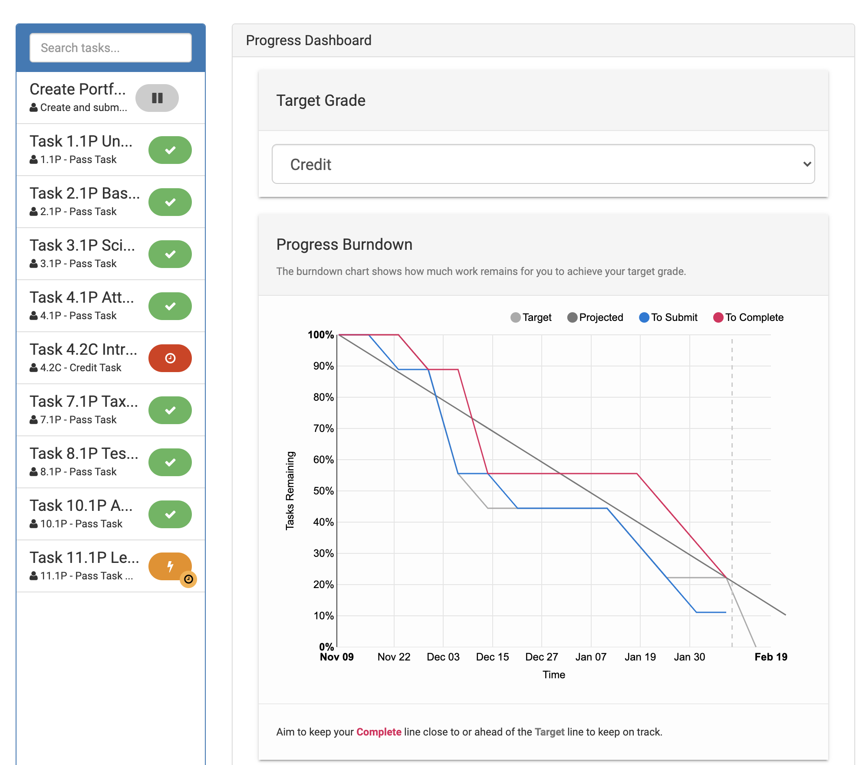

If I did this unit again, I would do the following things differently:
If I had to do this unit again I would try and attend the lectures and workshops live as, live interaction is a faster and better way to learn I feel. This is the first time I have ever studied online which was a big challenge to me. This will help fasten to process of getting answers to the queries that we have when we start learning something new

Important thing I learnt:
One important thing I learnt while studying this course while learning scripting, was about having attention to detail. That was one thing I always struggled with throughout my career as a chef. Being a Chef is hard work and is always about instinctive cooking and pace of work. But in scripting it is all about your knowledge and attention to detail, even a spelling error can cause a flaw or change the meaning of the code

